# **Planning and Progress Report D01**



|  |
| --- |
| **Group:** C1.031 |
| **Repository:** https://github.com/aaronma300604/DP2-C01-31 |
| **Members:**  **Student #1:** López Ramos, Daniel ([danlopram@alum.us.es](mailto:danlopram@alum.us.es))  **Student #2:** Ángel Postigo, Estrella ([estangpos@alum.us.es](mailto:estangpos@alum.us.es))  **Student #3:** Miranda Balastegui, Iván ([ivamirbal@alum.us.es](mailto:ivamirbal@alum.us.es))  **Student #4:** Terrón Hernández, Diego ([dieterher@alum.us.es](mailto:dieterher@alum.us.es))  **Student #5:** Mayoral Ansias, Aarón ([aarmayans@alum.us.es](mailto:aarmayans@alum.us.es)) |
| **Date:** Seville February 19, 2025 |

**Table of Contents**

**Planning and Progress Report D01** 1

**Table of Contents** 2

**Executive Summary** 3

**Revision Table** 3

**Introduction** 3

**Contents** 4

**Planning Chapter** 4

**List of Tasks** 4

**Screenshots** 6

**Budget** 7

**Progress Chapter** 8

**Progress Records** 8

**Conflicts** 9

**Final Costs** 9

**Conclusion** 10

**Bibliography** 10

# **Executive Summary**

This report contains information about the planning of the deliverable 01 and whether it was satisfied or not. The specific content will be based on the list of completed tasks, the estimated effort, the progress of these tasks throughout the deliverable, task distribution, amortization costs, and other activities related to the issues specified in the document “06-Annexes”.

# **Revision Table**

|  |  |  |
| --- | --- | --- |
| **Revision Number** | **Date** | **Description** |
| 1.0 | 19/02/2025 | Initial version – all sections added |

# **Introduction**

This report provides a structured overview of the planning and progress stages of the project, ensuring a clear and organized approach to tracking its execution. It is divided into two main chapters: **Planning** and **Progress**, each detailing key aspects of the project’s workflow, resource allocation, and performance evaluation.

The **Planning chapter** outlines the initial steps taken to meet the deliverable requirements, including a breakdown of tasks with relevant details such as responsibilities, estimated and actual time, and supporting screenshots documenting the development stages. Additionally, a detailed budget analysis is included, covering estimated work hours, personnel costs, and amortization using a linear method over three years.

The **Progress chapter** presents an analysis of the project's development, featuring recorded progress metrics, performance evaluations, and conflict resolution strategies. It also includes a comparison between the initial budget forecast and the actual costs incurred, ensuring transparency in project execution.

To maintain efficiency and accuracy, a project management tool has been utilized to facilitate report generation and automate relevant processes. This approach ensures that the report remains comprehensive, structured, and aligned with the predefined working methodology.

# **Contents**

## **Planning Chapter**

### **List of Tasks**

In this section, all the tasks that the group has determined as necessary to meet the requirements of the project’s first deliverable are listed.

1. **Instantiate and customise the starter project**: The name of the project folder, maven configuration (pom.xml), and database is “Acme-ANS-D〈dd〉”, where “〈dd〉” denotes the deliverable number using two digits. Was assigned to **Aarón**. Approximate hours: 2.
2. **Previous knowledge report about the architecture of a WIS:** Produce a report on what you knew about the architecture of a WIS before this subject. Was assigned to **Daniel.** Approximate hours: 5.
3. **Previous knowledge report about testing a WIS:** Produce a report on what you knew about testing a WIS before this subject. Was assigned to **Estrella and Diego.** Approximate hours: 5.
4. **Produce a chartering report:** Use the guidelines and structures from the "06-Annexes" file. Was assigned to **all the group.** Approximate hours: 5.
5. **Development configuration report:** Produce a report on how you have set up your development configuration. You must not reproduce the guideline to set it up, but to make it clear that you have followed it, and you have your development configuration ready to work. Was assigned to **Aarón.** Approximate hours: 5.
6. **Make planning dashboard derivable 1:** Provide the link of the dashboard in the requirements document of the group. Was assigned to **Daniel and Iván.** Approximate hours: 2.
7. **Produce a planning and progress report:** Use the guidelines and structures from the "06-Annexes" file. Was assigned to **Daniel, Estrella and Aarón.** Approximate hours: 3.
8. **Produce an analysis report:** Use the guidelines and structures from the "06-Annexes" file. Was assigned to **Iván and Diego.** Approximate hours: 3.
9. **Modify Anonymous menu (Student 1):** Modify the anonymous menu so that it shows an option that takes the browser to the homepage of your favourite website. The title must read as follows: “〈id-number〉: 〈surname〉, 〈name〉”, where “〈id-number〉” denotes your DNI, NIE, or passport number, “〈surname〉” denotes your surname/s, and “〈name〉” denotes your name/s. Was assigned to **Daniel.** Approximate hours: 0.5.
10. **Modify Anonymous menu (Student 2):** Modify the anonymous menu so that it shows an option that takes the browser to the homepage of your favourite website. The title must read as follows: “〈id-number〉: 〈surname〉, 〈name〉”, where “〈id-number〉” denotes your DNI, NIE, or passport number, “〈surname〉” denotes your surname/s, and “〈name〉” denotes your name/s. Was assigned to **Estrella.** Approximate hours: 0.5.
11. **Modify Anonymous menu (Student 3):** Modify the anonymous menu so that it shows an option that takes the browser to the homepage of your favourite website. The title must read as follows: “〈id-number〉: 〈surname〉, 〈name〉”, where “〈id-number〉” denotes your DNI, NIE, or passport number, “〈surname〉” denotes your surname/s, and “〈name〉” denotes your name/s. Was assigned to **Iván.** Approximate hours: 0.5.
12. **Modify Anonymous menu (Student 4):** Modify the anonymous menu so that it shows an option that takes the browser to the homepage of your favourite website. The title must read as follows: “〈id-number〉: 〈surname〉, 〈name〉”, where “〈id-number〉” denotes your DNI, NIE, or passport number, “〈surname〉” denotes your surname/s, and “〈name〉” denotes your name/s. Was assigned to **Diego.** Approximate hours: 0.5.
13. **Modify Anonymous menu (Student 5):** Modify the anonymous menu so that it shows an option that takes the browser to the homepage of your favourite website. The title must read as follows: “〈id-number〉: 〈surname〉, 〈name〉”, where “〈id-number〉” denotes your DNI, NIE, or passport number, “〈surname〉” denotes your surname/s, and “〈name〉” denotes your name/s. Was assigned to **Aarón.**
14. **Link to the dashboard:** Provide a link to your planning dashboard in GitHub to review the tasks, their current status, and your schedule. Was assigned to **all the group.** Approximate hours: 0.5.
15. **Decide language of the project:** The default language must be English, but Spanish must be supported, as well. Other mainstream languages are welcome but not required. This requirement must be met in this and every other group or individual deliverable for it to be considered satisfied. Was assigned to **Daniel.** Approximate hours: 1.
16. **Issue deleted.**
17. **Issue deleted.**
18. **Update README with useful information:** This file has to include at least an introduction, the members and useful links for next deliverables. Was assigned to **Daniel.** Approximate hours: 1.

### **Screenshots**

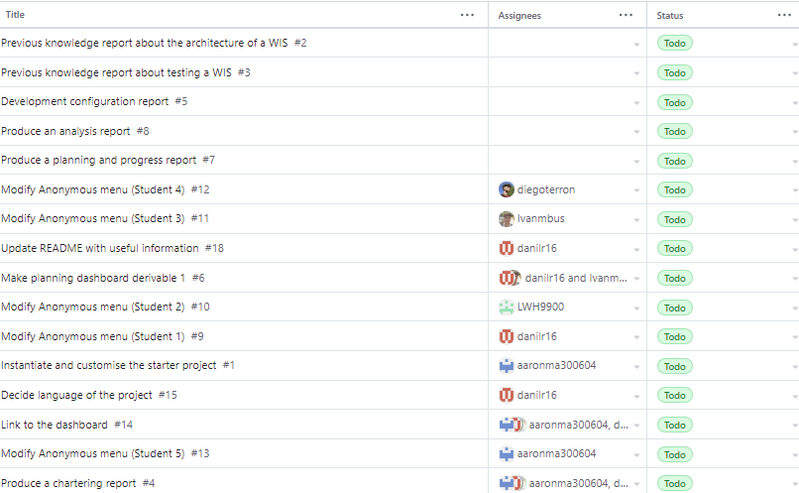

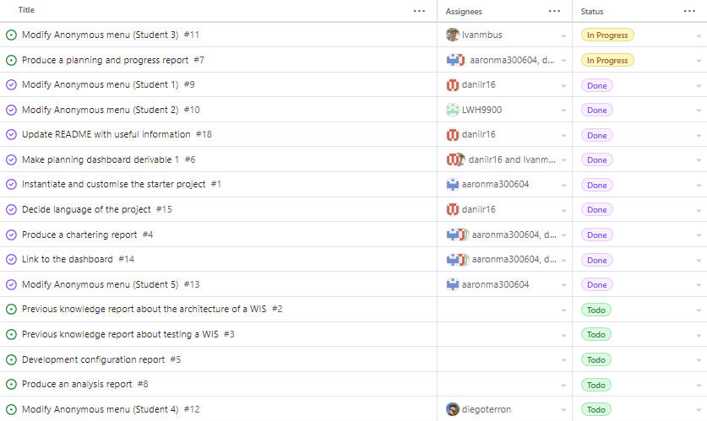

### **Budget**

To calculate the budget, we have taken into account one worker for each role: a manager, an analyst, a tester, a developer and an operator. For the manager and the analyst, we have approximated a cost per hour of €30.00, and for the rest of employees, a cost per hour of €20.00.

|  |  |  |  |
| --- | --- | --- | --- |
| **Task** | **Role(s)** | **Hours per role** | **Total Cost (€)** |
| #1 | Manager | 2 | 60 |
| #2 | Analyst | 1 | 30 |
| #3 | Operator, developer | 1,1 | 40 |
| #4 | Manager, analyst, developer,  tester, operator | 1,1,1,1,1 | 120 |
| #5 | Manager | 1 | 30 |
| #6 | Analyst, tester | 1,1 | 50 |
| #7 | Manager,analyst,developer | 1,1,1 | 80 |
| #8 | Tester,Operator | 1.5,1.5 | 60 |
| #9 | Analyst | 0.5 | 15 |
| #10 | Developer | 0.5 | 10 |
| #11 | Tester | 0.5 | 10 |
| #12 | Operator | 0.5 | 10 |
| #13 | Manager | 0.5 | 15 |
| #14 | Manager, analyst, developer,  tester, operator | 0.5,0.5,0.5,0.5,0.5 | 60 |
| #15 | Analyst | 0.5 | 15 |
| #16 |  |  |  |
| #17 |  |  |  |
| #18 | Analyst | 1 | 30 |

To calculate the amortisation, we sum up all the costs and divide by 3 years. Doing this, the annual amortisation formula gives an approximate of 212€/year.

## **Progress Chapter**

### **Progress Records**

Daniel López Ramos - Analyst - Completed 8/16 issues

Estrella Ángel Postigo - Developer - Completed 4/16 issues

Aarón Mayoral Ansias - Manager - Completed 6/16 issues

Diego Terrón Hernández - Operator - Completed 5/16 issues

Iván Miranda Balastegui - Tester - Completed 5/16 issues

We will follow the performance indicators of our project:

* Work done: Fully covered.
* Work to be done: Approved.
* Distance to objective grade: Pending estimation.
* Follow software good practices: Approved.

The team’s performance has been satisfactory for all members of the team. Communication has been clear, and all tasks were coordinated effectively. There have been no problems or conflicts.

### **Conflicts**

There wasn’t any conflicts in this deliverable.

### **Final Costs**

Regarding the final costs, following the same cost per hour as in the budget projection, the costs and hours have been:

|  |  |  |  |  |
| --- | --- | --- | --- | --- |
| **Task** | **Role(s)** | **Hours per role** | **Estimated**  **(€)** | **Final cost**  **(€)** |
| #1 | Manager | 2 | 60 | 60 |
| #2 | Analyst | 1 | 30 | 30 |
| #3 | Operator, developer | 1,1 | 40 | 40 |
| #4 | Manager, analyst, developer,  tester, operator | 1,3,2.5,2.5,2.5 | 120 | 270 |
| #5 | Manager | 1.5 | 30 | 45 |
| #6 | Analyst, tester | 1,1 | 50 | 50 |
| #7 | Manager,analyst,developer | 2,2,2 | 80 | 80 |
| #8 | Tester,Operator | 1.5,1.5 | 60 | 60 |
| #9 | Analyst | 0.5 | 15 | 15 |
| #10 | Developer | 0.5 | 10 | 10 |
| #11 | Tester | 0.5 | 10 | 10 |
| #12 | Operator | 0.5 | 10 | 10 |
| #13 | Manager | 0.5 | 15 | 15 |
| #14 | Manager, analyst, developer,  tester, operator | 0.5,0.5,0.5,0.5,0.5 | 60 | 60 |
| #15 | Analyst | 0.5 | 15 | 15 |
| #16 |  |  |  |  |
| #17 |  |  |  |  |
| #18 | Analyst | 0.5 | 30 | 15 |

The total final cost is 262€/year instead of the 212€/year that were approximated.

# **Conclusion**

The planning and execution of Deliverable 01 have been successfully carried out following a structured and well-coordinated approach. The team effectively distributed tasks, adhered to the established methodologies, and maintained clear communication throughout the process.

The use of project management tools facilitated organization and tracking, ensuring transparency and efficiency. The budget estimation closely matched the final costs, with some variations due to additional efforts required in specific tasks. These insights will be valuable for optimizing future deliverables and improving time allocation strategies.

# **Bibliography**

Intentionally blank.